Pages 52 ***Java Programming A Comprehensive Introduction***

**Character Escape Sequences-**

**\’** – Insert Single quote.

**\”** – Insert double quote.

**\\** - Insert slash \.

**\r** – erase the sentence before \r.

**\n** – next line.

**\f –** make a space between two word.

**\t –** tab, is a five space

**\b –** cut the first last alphabet of the word.

Pages 892-893 ***Java Programming A Comprehensive Introduction***

Format Specifier-

**"** **%.**2f **"-** Describe what the statement is saying- float will be a two decimal place.

“%n”- Describe what the statement is saying- new line

**System.out.format("%.2f%n", b + a); // Example of code**

System.out.format(…); Explain how this method differs from System.out.println –

Println is use for the string only but System.out.format(..) use for format decimal restriction.

What is the difference between System.out.print and System.out.printf ?

System.out.print prints prompts only that are inside double quotation, while System.out.printf is not to print the sting, instead use to strict the float decimal place.

Print the sentence… Using a single. System.out.println. Include your name in “” quotes. Do not use + Attach a small snipping photo below.

**Jave is Great “YourName” I am really learning a lot!**

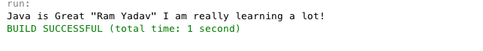

**1st Task:** Using **If** and **else** ladder. Write a program that computes a single filer’s income tax burden.

|  |  |
| --- | --- |
| **TAX RATE** | **Single Filers Income** |
| 10% | Up to $6000 |
| 15% | $6,001 - $27,950 |
| 27% | $27,951 - $67,700 |
| 30% | $67,701 - $141,250 |
| 35% | $141,251 - $307,050 |
| 38.6% | $307, 051 or more |

The user should be able input her Income.

The output can be a simple system.out.printf output.

Please create a whiteboard or pseduecode process. **Attach a Snipping Photo Below**

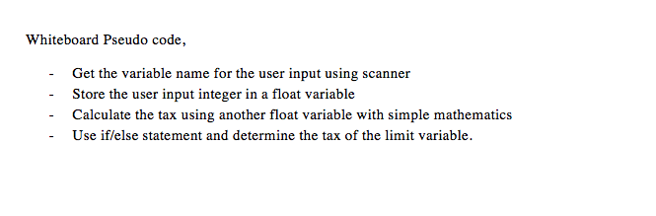

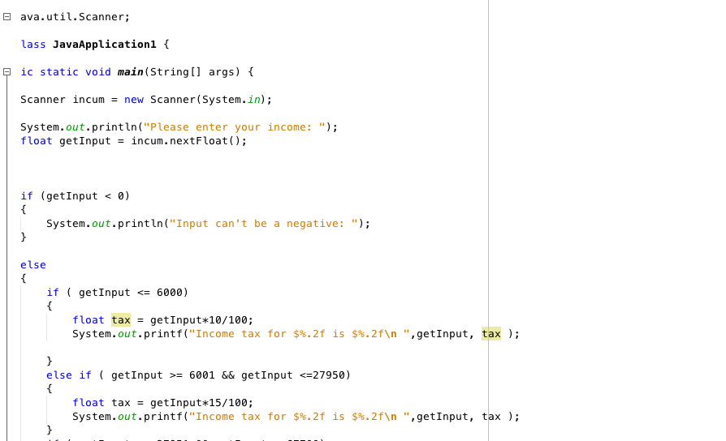

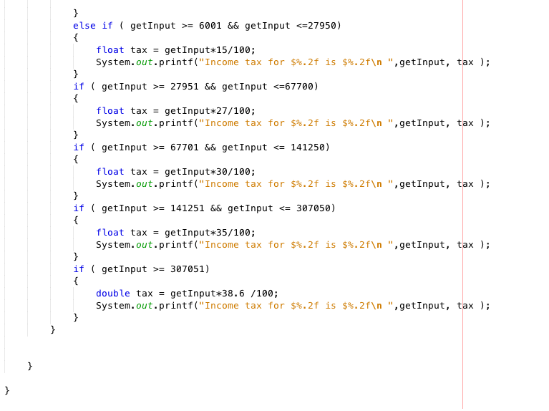

**Sample Output- //**Output should have proper formatting for dollars, 2 decimal places

Income tax for a single person making $85000.00 is $25500.00

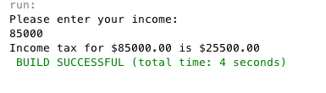

Output 2

Income tax for a single person making $9800.00 is $1470.00

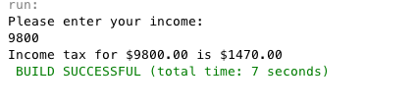

2nd Task:

Printing a Table:

Use Character Escape Sequences to

Write a program that displays the following table:

Formatting is Key! Match the Formatting and alignment

a b pow(a, b)

1 2 1

2 3 8

3 4 81

4 5 1024

5 6 15625